**How to create a member in ISG – Small Group**

* Login in to Mainframe using command **“ism”**
* Give your credentials.
* Choose the test region where you want to create the member ex:- **IMSW/IMSN**
* Give pause/break and **“/test mf”**
* For creating a ISG individual or small group members GOTO profile **“STARMM01 ”**
* For small group option is **AA** and for individual option **is BA**

**Small group**

* Choose option **“AA”** for small group
* Choose option **“AA”** Employer group
* We have to create an entity first, so choose option **“AA” – Add Bill Entity**
* Fill the below details: - Mandatory fields. Rest you can fill random data.

**ST/BUS CODE** give the state name for which you are creating.

**ZIP code** of that state – you can google it.

**XCHG IND** is for on/off exchange. So for off exchange give “**OF”** and for on exchange give **“PB”**

**GROUP TYPE is** normally we give **“02”** for small group.

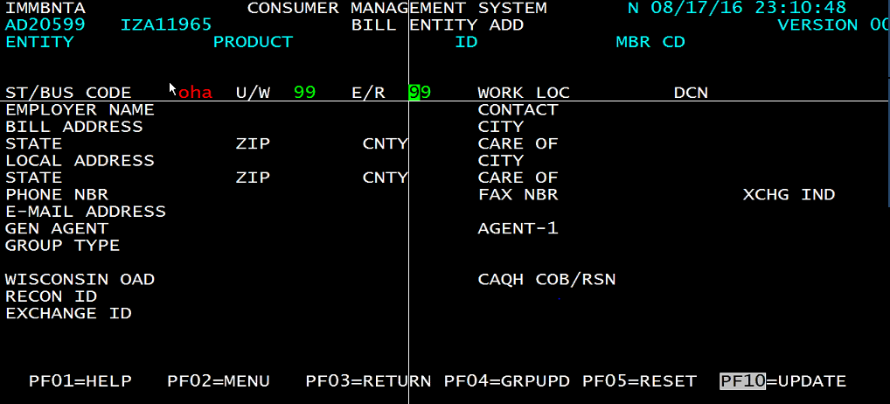

* **Press F10**

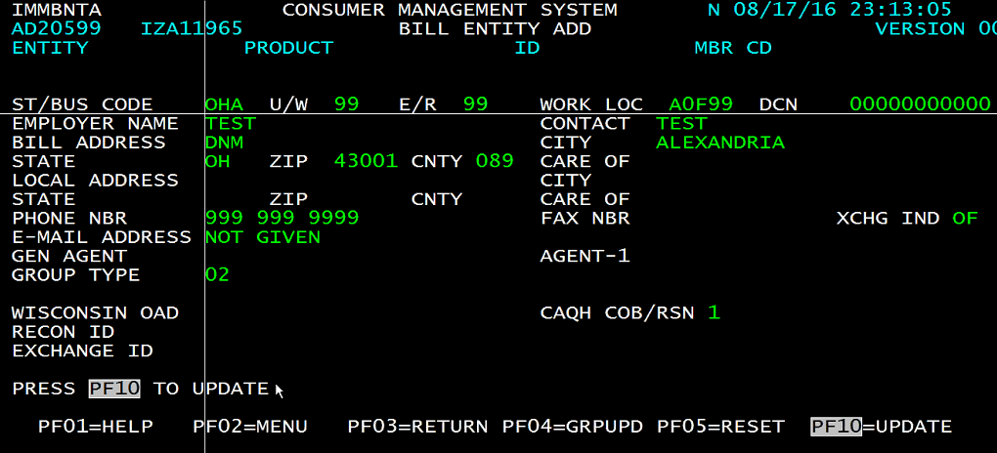

**Caution: -** when you see below message do not press enter or anything. Otherwise the entity will go waste.

**“EMPLOYER GROUP SUCCESSFULLY ADDED”**

* Press **F4** for group update then it will go to next screen. Then we have to give the wait option random no for waiting like 01 sec or 02 sec in **STF LVL CD1/DC2**.

Also give effective date in **GRP EFFDT** field.

**ACCT MGR** and **SALES REP** are constant values (10440)

**BRK IND –** broker indicator we can give **“T”**

**Then press F10** and then stop after it shows update complete. Don’t give anything.

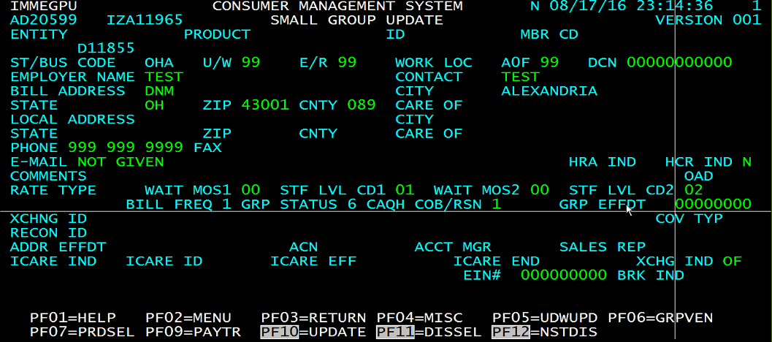

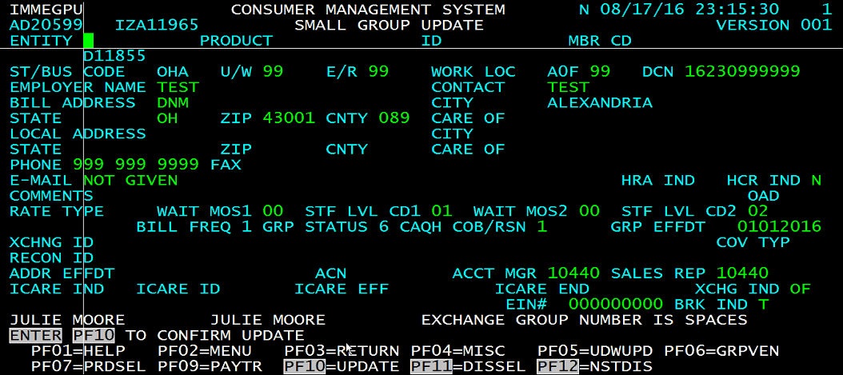

* Give **F7** product select to select the product. Choose a product from the below screen.

Select MED

For small group **SIZE** is less than 50 so give **0049**

Employee plan **EMP PLAN** give **“ma”** for medical, for dental give “da”, for vision give “va”.

MEDICARE PRIME give **“N”** coz it’s not Medicare

SIC CODE is same for all 08999

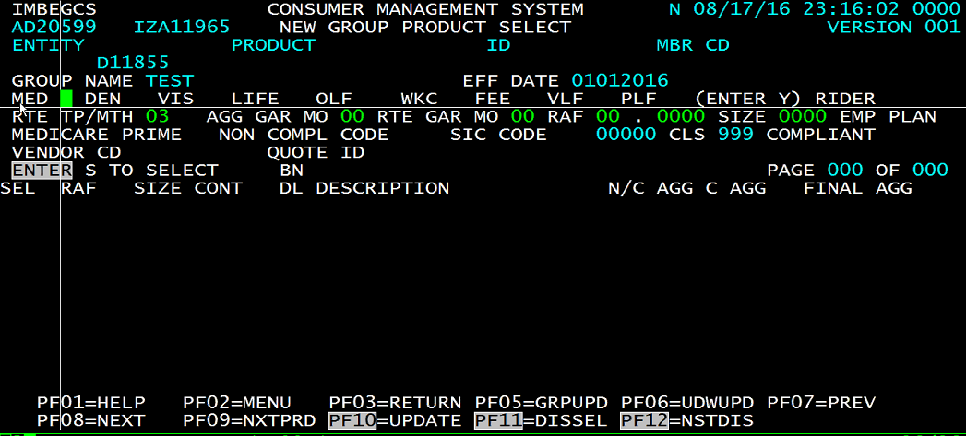

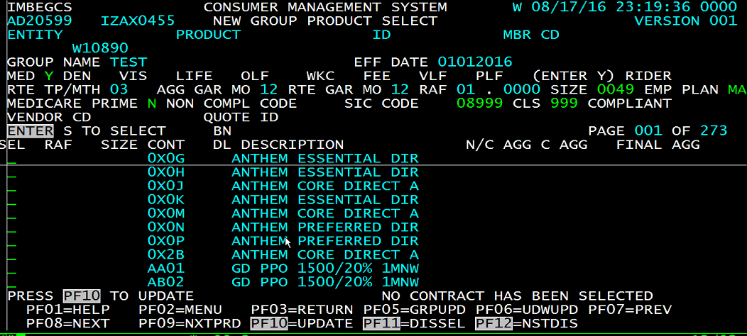

* Now look for contract code, if you haven’t received any. You have to select the contract code based on your scenario from the list. Inquire the product code **PM>AP>AI** option and choose the appropriate contract code, if alpha prefixed also mentioned cross check that as well.

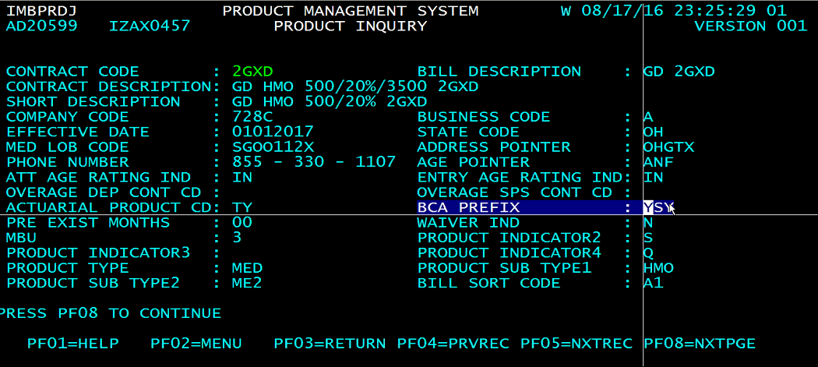

* Check for the product code, if mentioned in the request for that contract. GOTO **“CA” CUSTOMER SERVICE, then “HH” CONTRACT PROFILE. Give the contract no and “AA” GENERAL INFO.** Check the product whether it is same which you are looking for in the **PRODUCT** field.
* If everything satisfy then select the contract and **press F10** to update. If you want to select more than one contract press **PF9** or you can press **F6** to under writing screen.

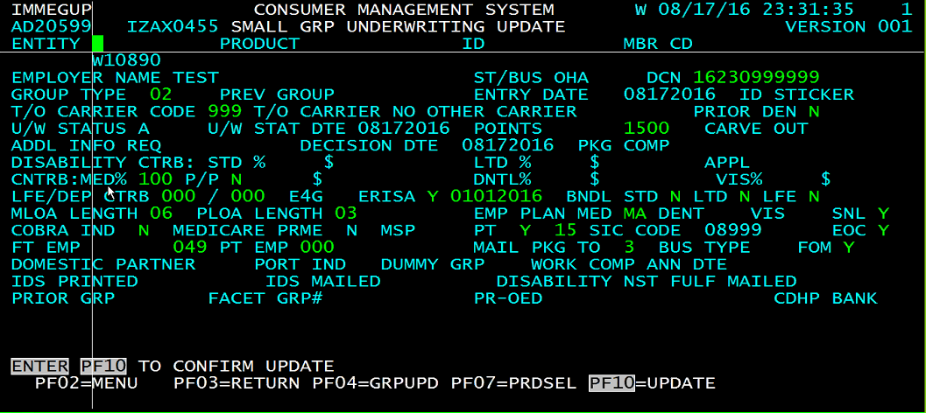

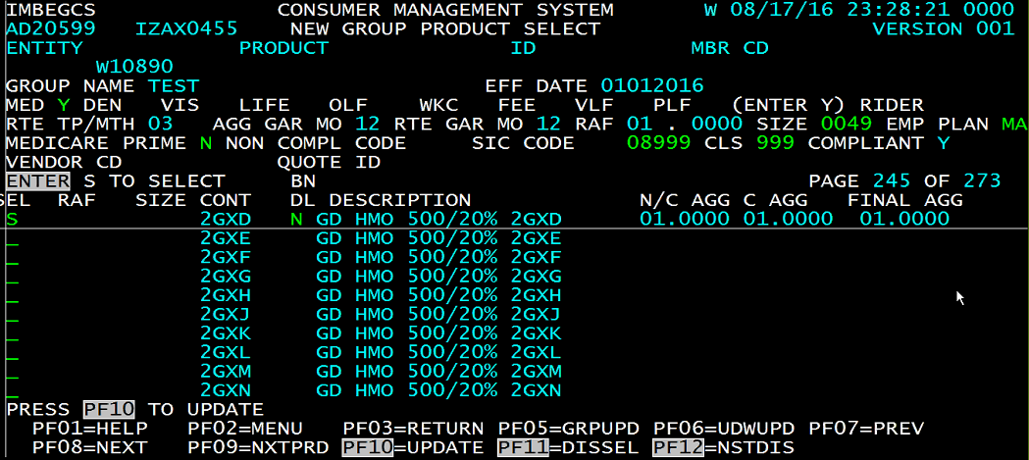

* Press enter in under writing screen it will take you to mandatory fields.

PRIOR DEN = “N”

COBRA IND = “N”

EOC/FOM = n or y

T/O CARRIER CODE = 999

U/W STATUS is in “P” that means it is in pend status and if it is “A” that means active. **If you don’t give status as “A” you won’t be able to create member under it then press Enter for other mandatory fields.** Randomly gives some POINTS.



* To check the benefits. GOTO option CA>>HH>BC

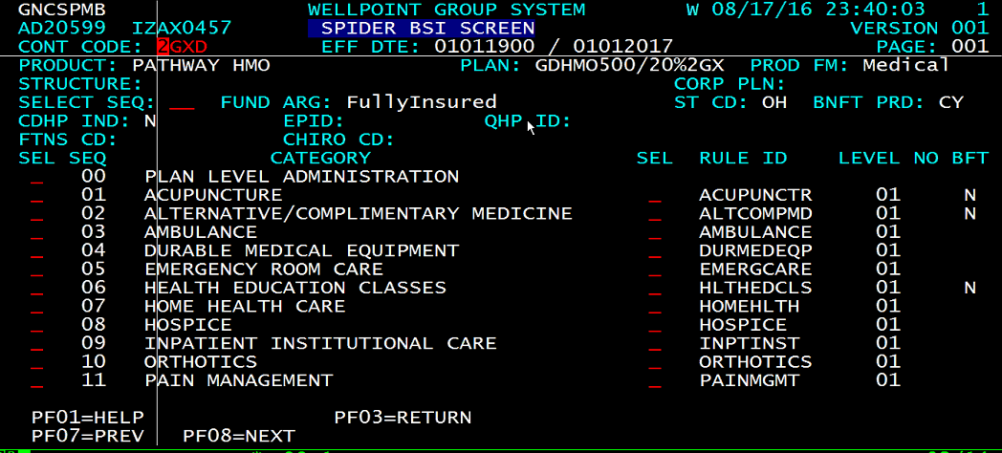

* Give the default TIN and press F10.

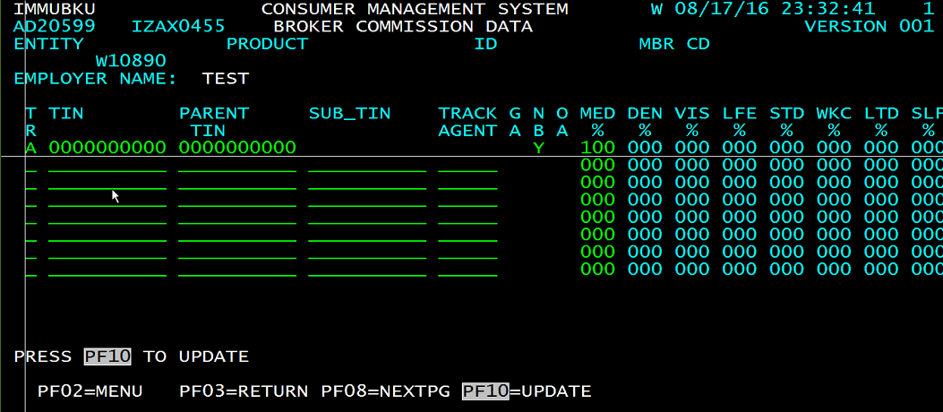

**Update complete message will be display that means we have completed creating the entity**

**Member creation under the entity**

* For creating a member go under small group again using option

Choose option **“AA”** for small group

* Choose option **“AA”** Employer group
* Choose option **“BA” SUBSCRIBER/DEPENDENT**
* Give some random no in ID and check whether that no is present or not. If not you can use that no and choose option **“AA”** ADD ENROLLMENT.
* Give the effective date, whatever effective date you have given in entity give that same effective date. Select the row and press F10.

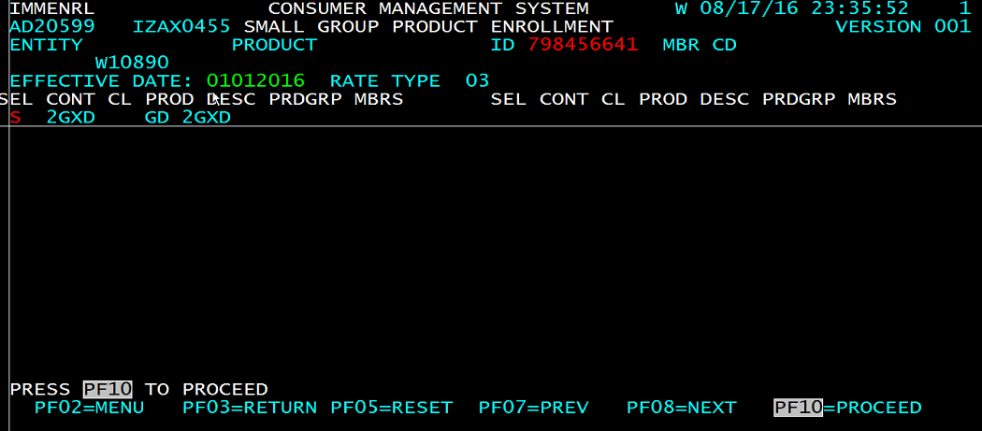

* Fill the details same as entity in the below screen and press F10

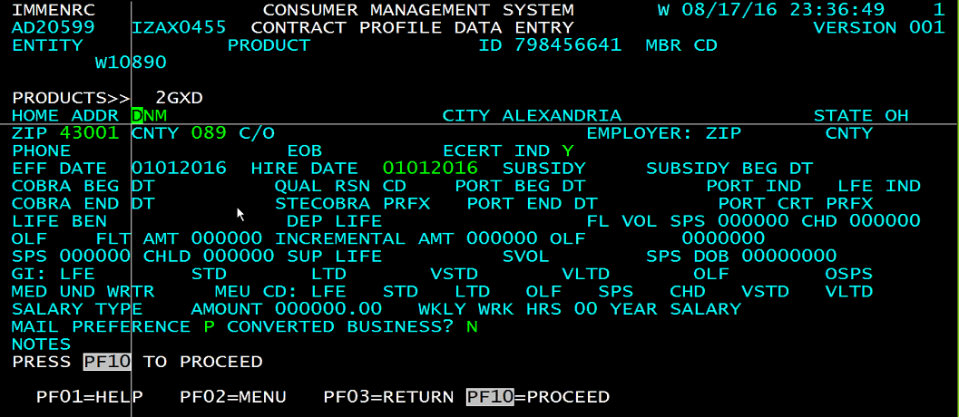

* Fill the info and F8 to add dependent. If no dependent then press F10. Enter the dependent

Details as well SEX CODE “1” for subscriber and “4” for spouse

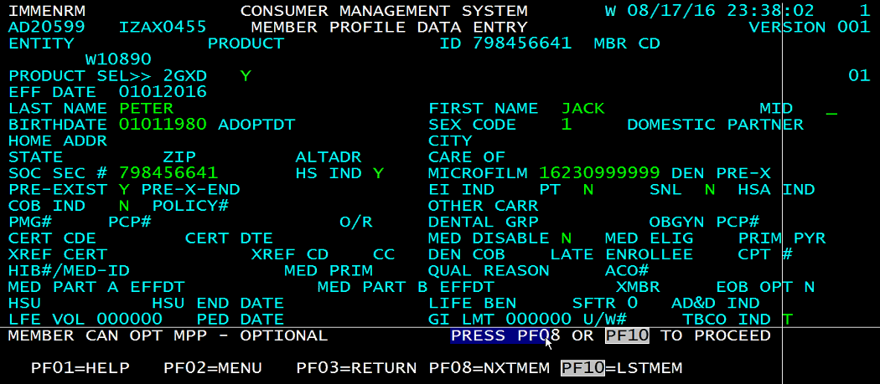

Dependent profile

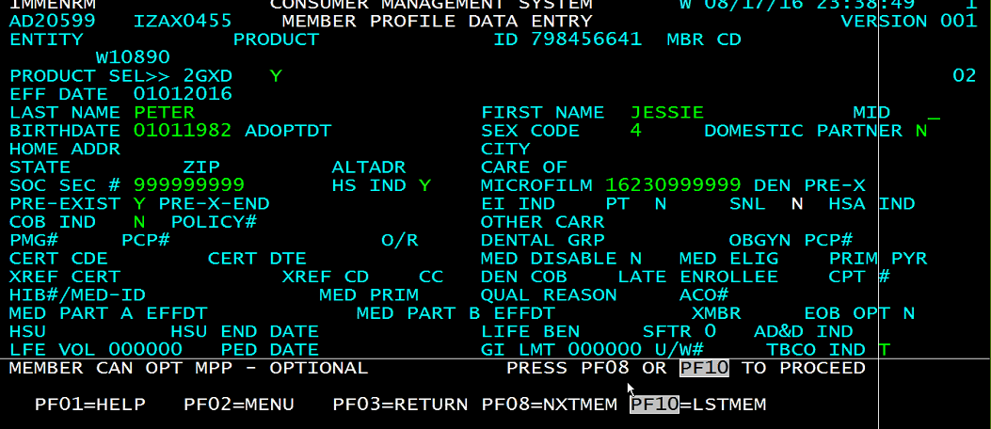

Press F10.

* Press F10 in the below screen.

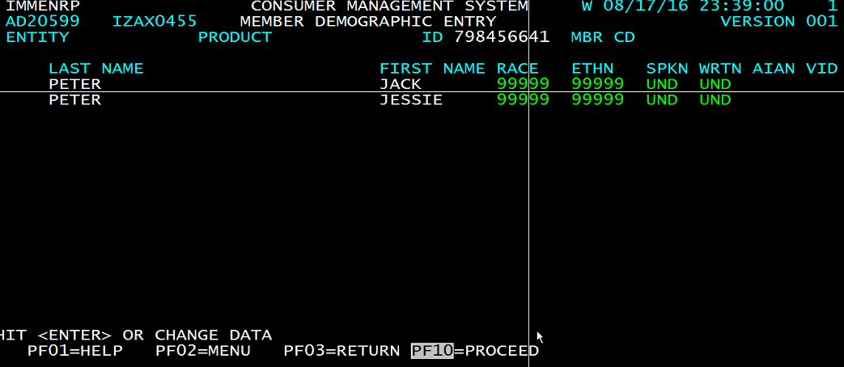

* Press F10

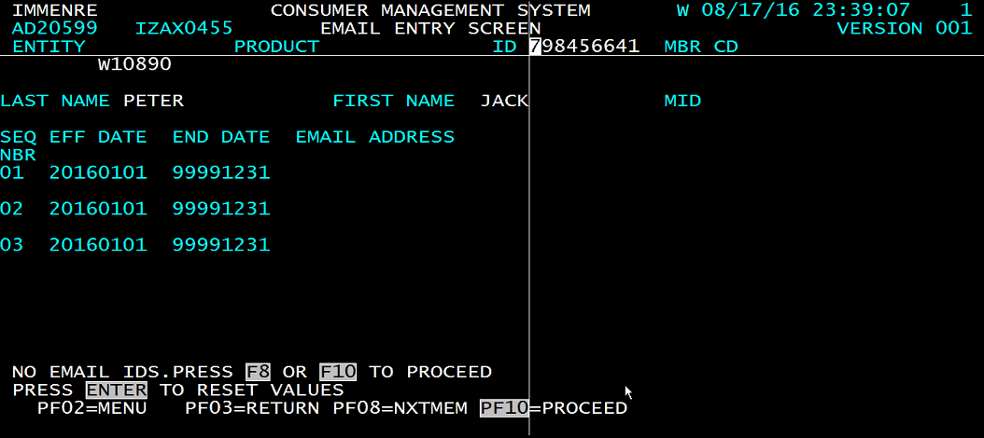

* Press enter and F10

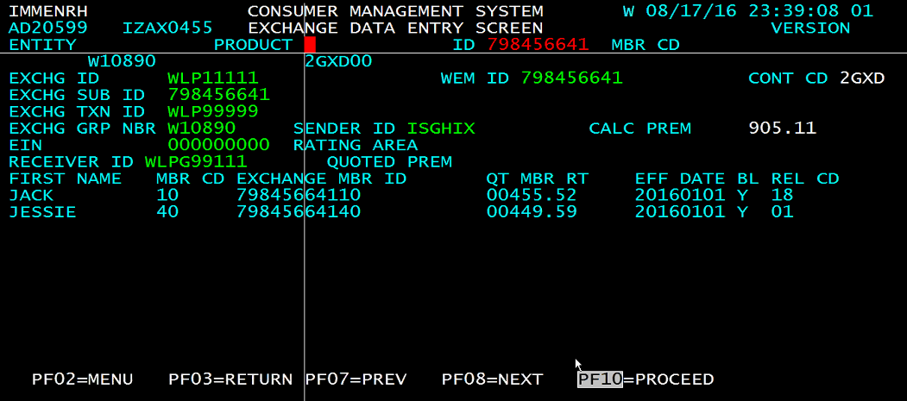

* Member created if you see HSCID populated and billing rate created.

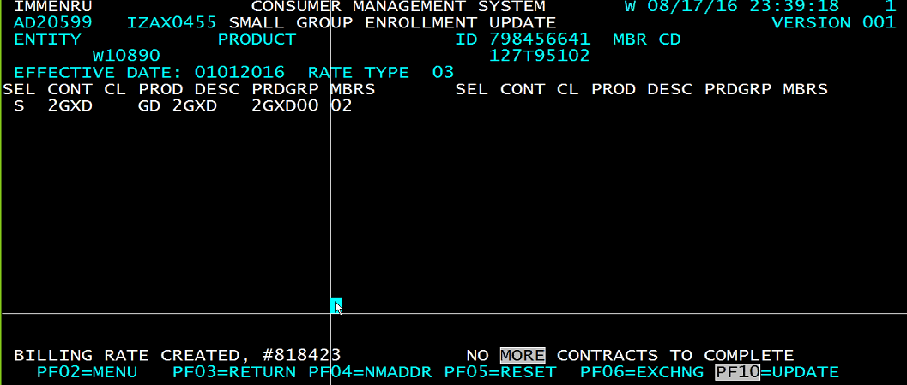

**Billing and Recon**

* To inquire the small group. Choose the option **“AA”** for SMALL GROUP.
* Choose option **“AA”** EMPLOYER GROUP.
* Choose option **“BC”** GROUP INQUIRY.

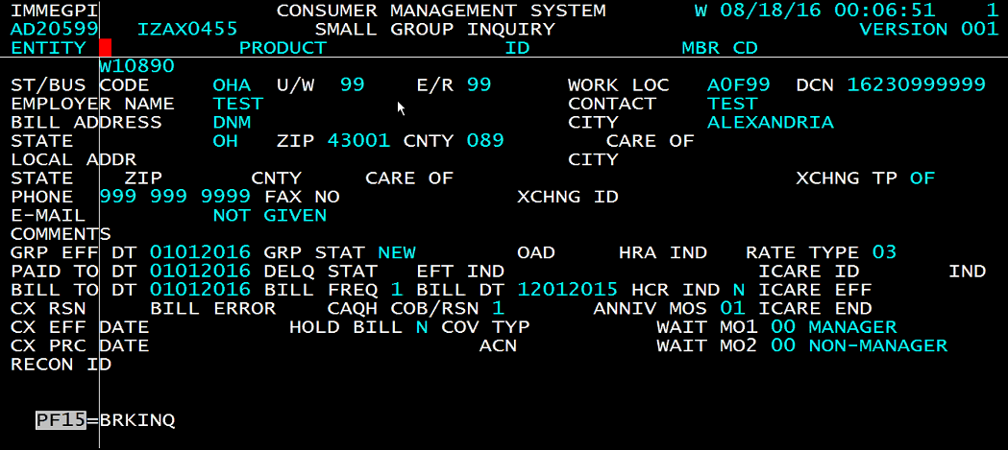

* How to request the bill for small group

Choose the option **“AA”** for SMALL GROUP.

Choose the option “**DB”** for STAR BILLING SYSTEM

Choose option **“CA”** REQUEST BILL

In INDIVIDUAL you can request bill and do reconciliation how many times you want in a day but in small group you can do only once. Be clear before request for how many months you want the bill in small group in **PERIOD FROM** & **PERIOD TO** fields and press **F10**

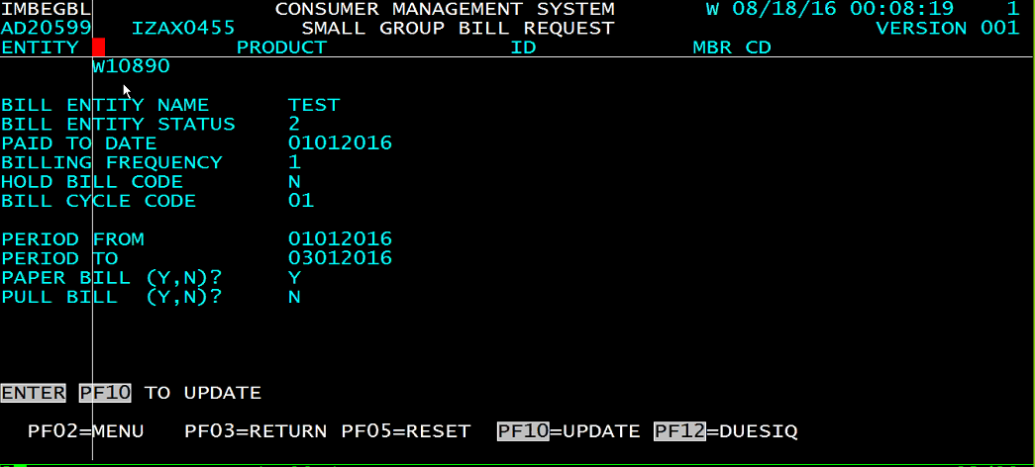

Once we request for the bill then we have to wait for batch run which will generate invoices. Better check next day.

* To check **invoices.** Choose option “**AA**” BILLING INQUIRY. Give the entity number.

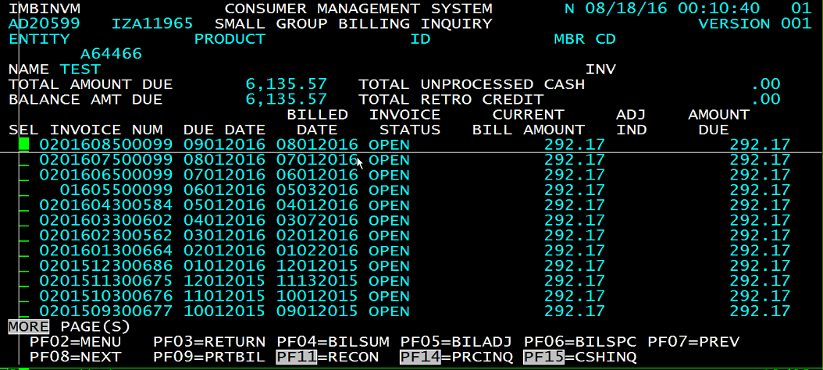

* Go for **“EA”** option CHECK SYSTEM
* Choose option “AC” CHECK BATCH ENTRY.

In MBU we have to give the state name A and i/g for individual or group.

In group field give entity name. in individual give the member name.

In RTN/ABA, TOT ITEMS ACCOUNT, CHK NBR give random numbers.

In individual we were taking due amount for CHK AMT but in small group give some random amount.

**Press F10. Copy no after pressing F10.**

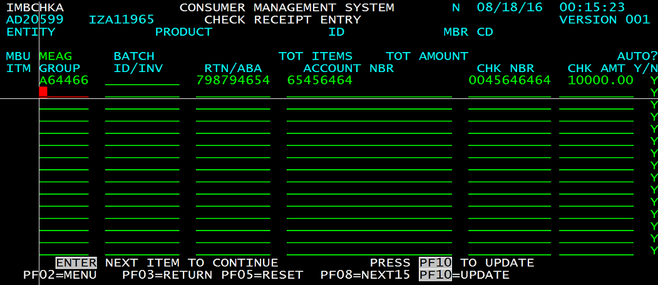

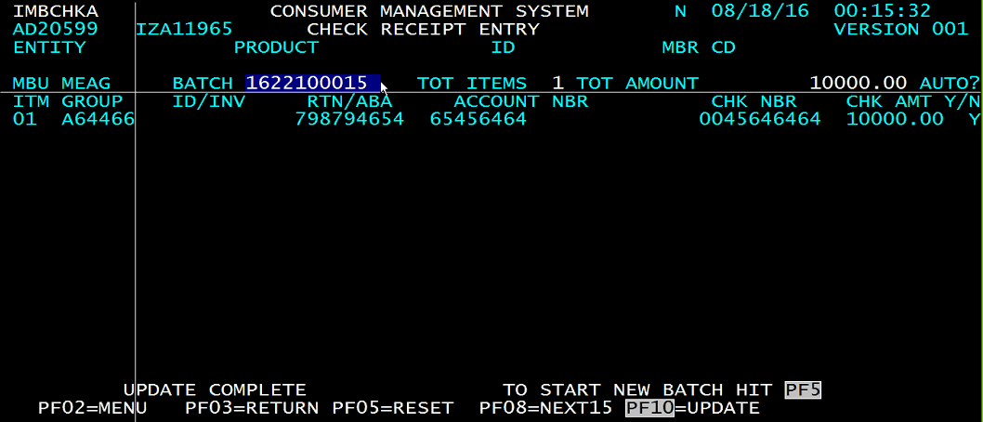

* GOTO **CD** - CHECK BATCH RELEASE. Fill STATE, MBU, and BATCH no we have copied.

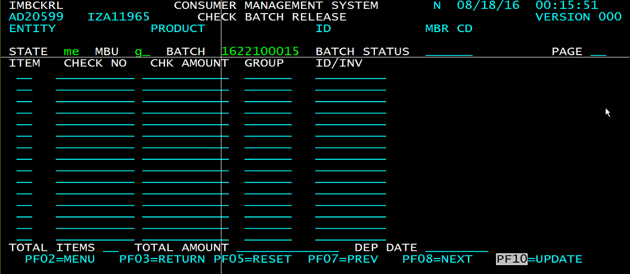

Enter

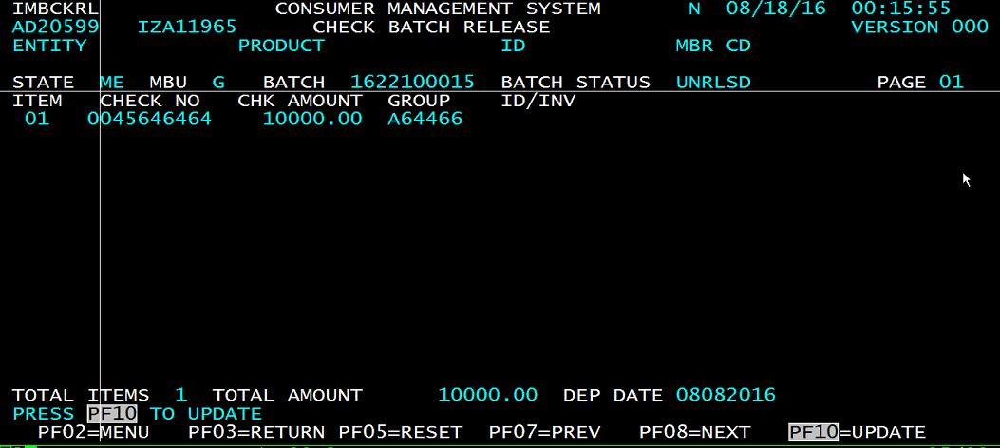

**Press F10.** Check has been dropped for the particular amount.

* Go back to the invoice inquiry option AA>DB>AA and inquire the invoice you can see unprocessed cash amount.

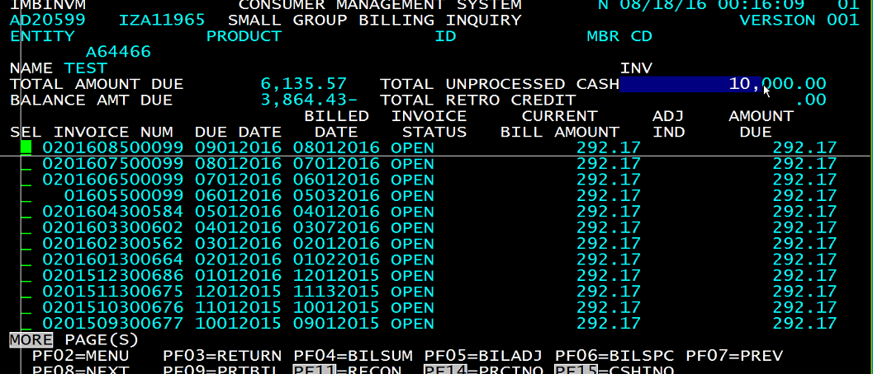

* Press F11 for RECON. Select the check and press F10

